Course Code: CSA1557

Course Name: Cloud Computing and Big Data Analytics

R.Pranusha

192111023

6) Create a simple cloud software application for Payroll Processing System using any Cloud Service Provider to demonstrate SaaS include the necessary fields such as Name of the employee, experience in present org , over all experience, basic pay, HRA, DA, TA, net pay, gross pay etc.

AIM: To Create a simple cloud software application for Payroll Processing System using any Cloud Service Provider to demonstrate SaaS.

PROCEDURE:

step1: Go to zoho.com.

step 2: Log into the zoho.com.

step 3: Select one application step.

step4: Enter application name as library book reservation system.

step 5: Created new application as library book reservation system.

step 6: Select one form

step 7: The software has been created.

IMPLEMENTATION:

STEP1: GOTO ZOHO.COM

STEP 2: LOGIN TO THE ZOHO.COM

STEP 3: SELECT ONE APPLICATION

STEP 4: ENTER APPLICATION NAME

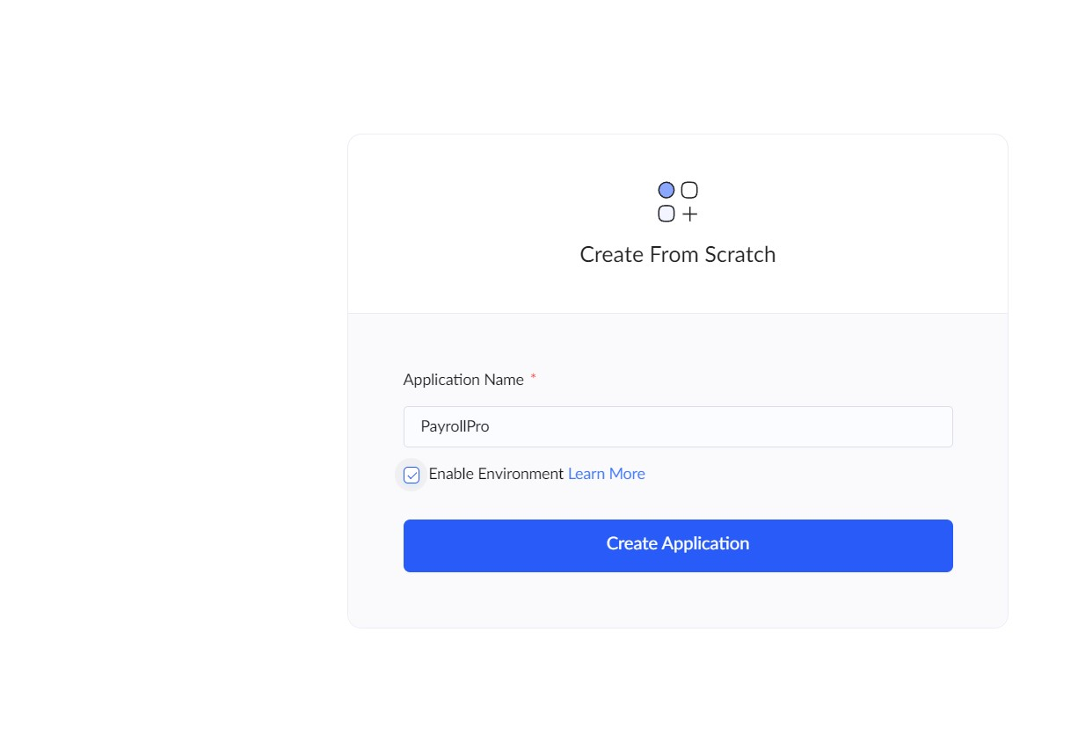

STEP 5: CREATED NEW APPLICATION as PayrollPro.

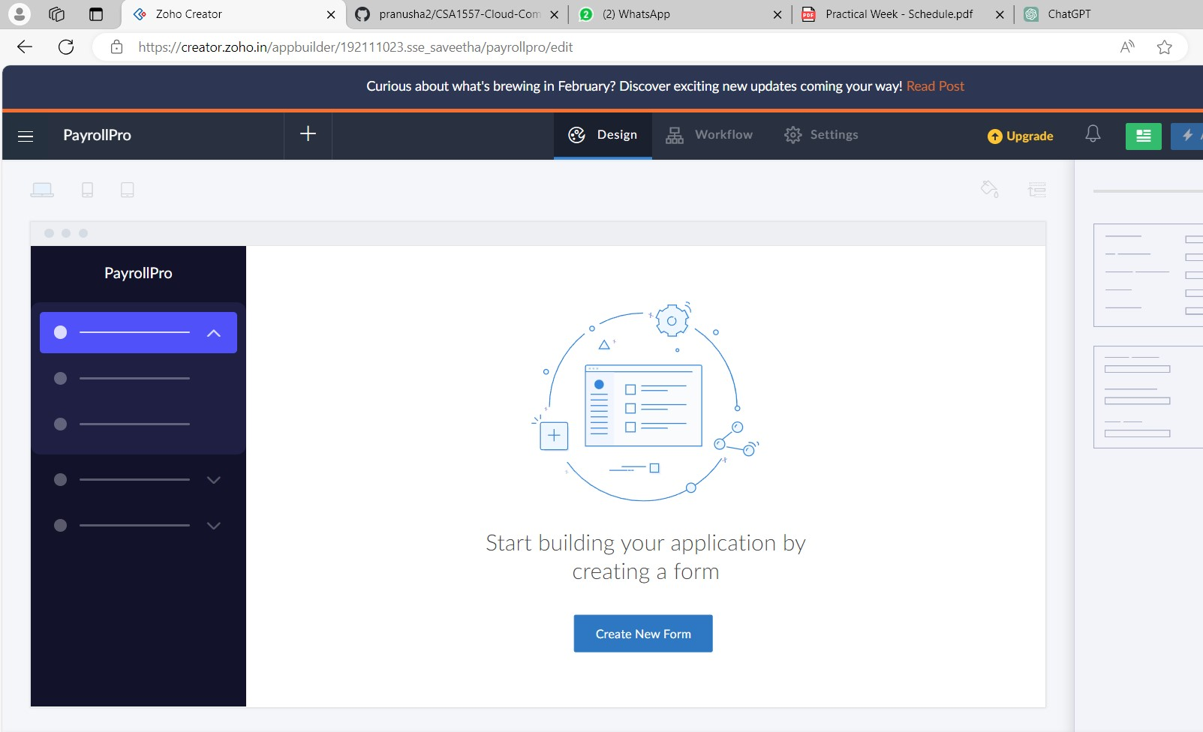

STEP 6: Select from Stratch and Create form as Payroll Processing system.

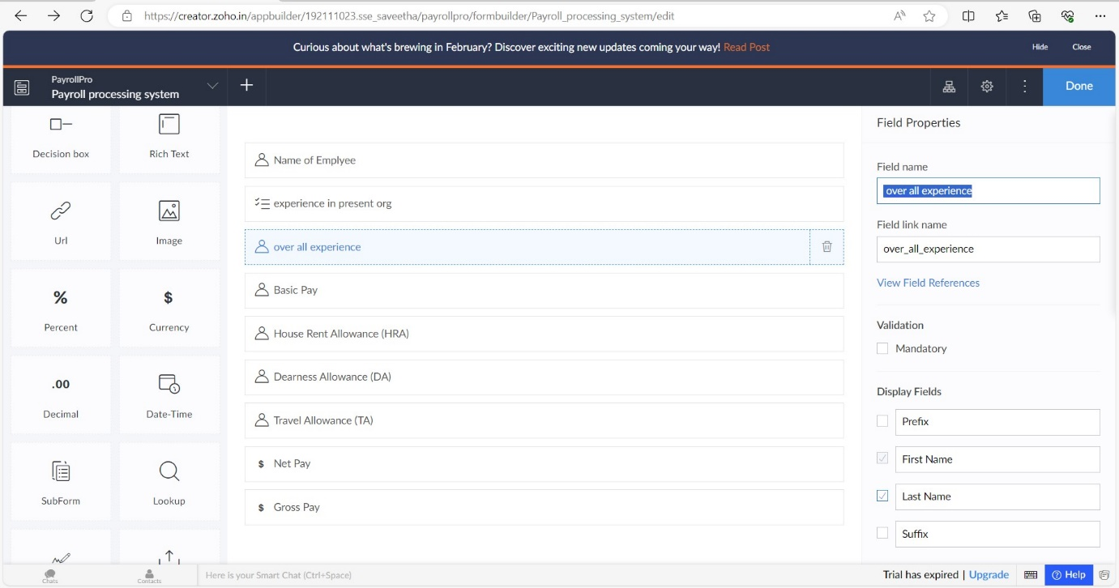

STEP 7: The form has been created as Payroll Processing system

Choose the fields.



STEP 8: Click Access Development Live

STEP 9: Enter the details of the Payroll Processing system.

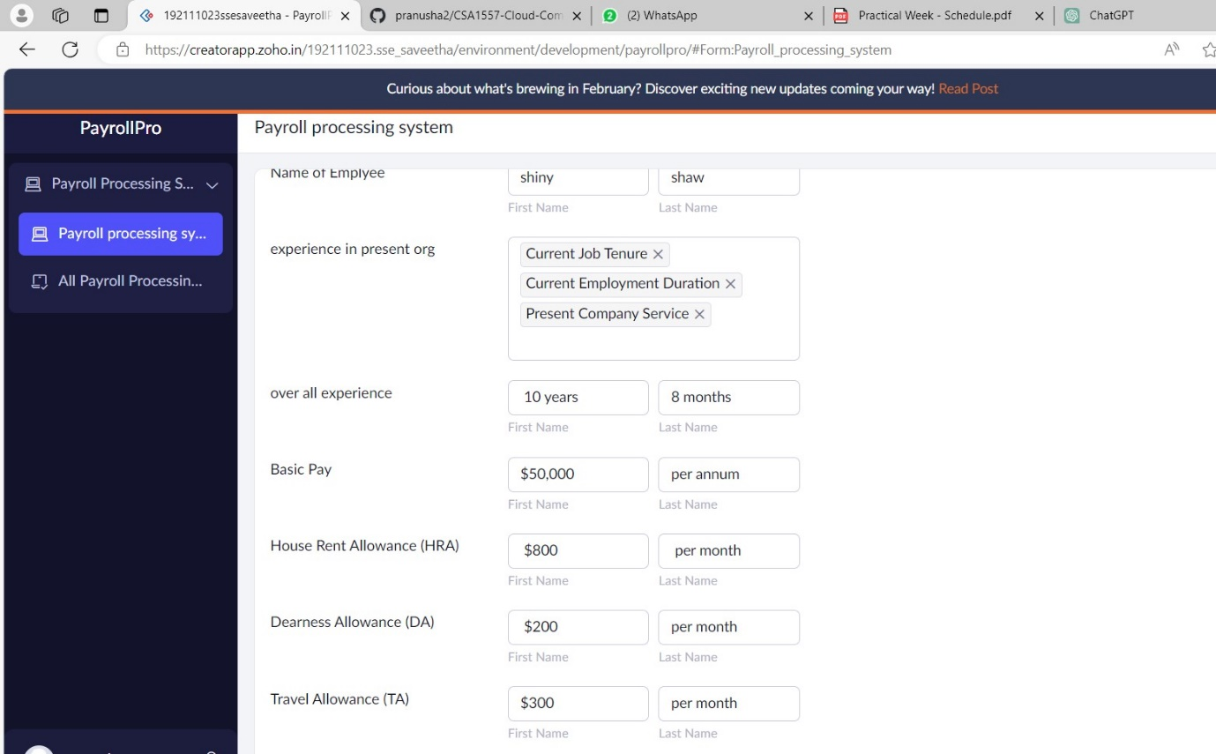

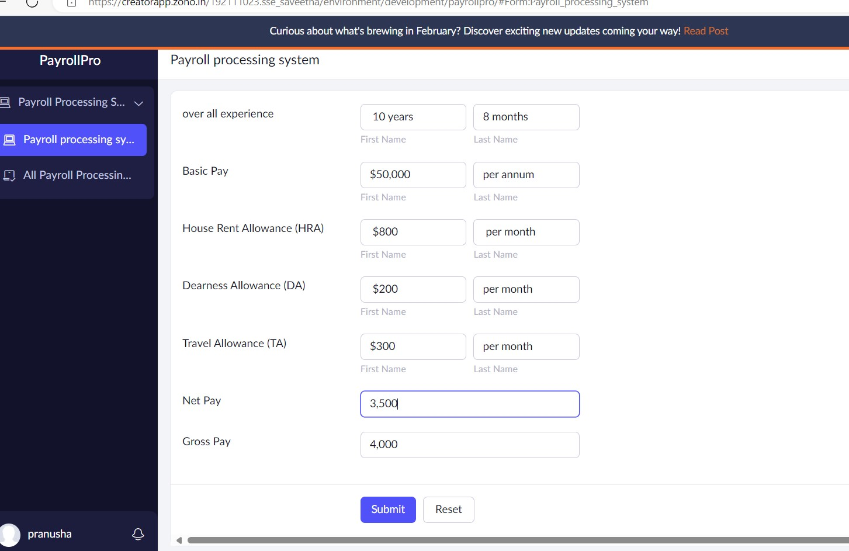

STEP 10: The report has been registered in the Payroll Processing system report.

